### Part j - Vertex AI:

### Export and deploy a BigQuery Machine Learning Model for Prediction

This document has screenshots of -

* Training a model with BigQuery Machine Learning (BQML)
* Exporting BQML model to Cloud Storage
* Deploying trained BQML to Vertex AI
* Get predictions on deployed model

The task is to train a Machine Learning model using BigQuery ML to predict the likelihood of defaulting a credit card payment. ML models can be trained on BigQuery ML and the predictions can be obtained just by using SQL

1. Creating notebook instance on vertex AI

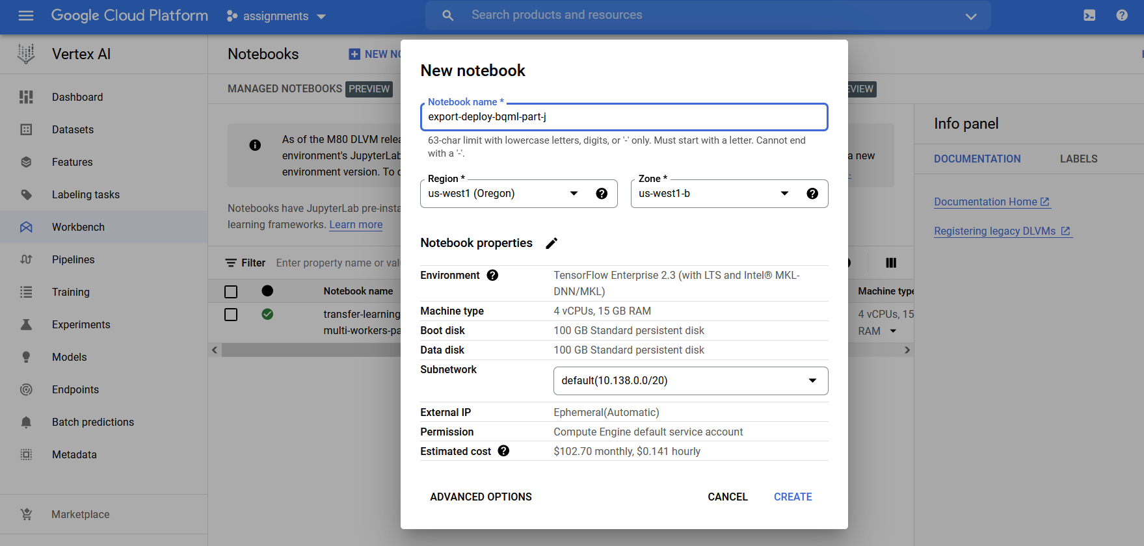

1. Creating a dataset in BigQuery within the project

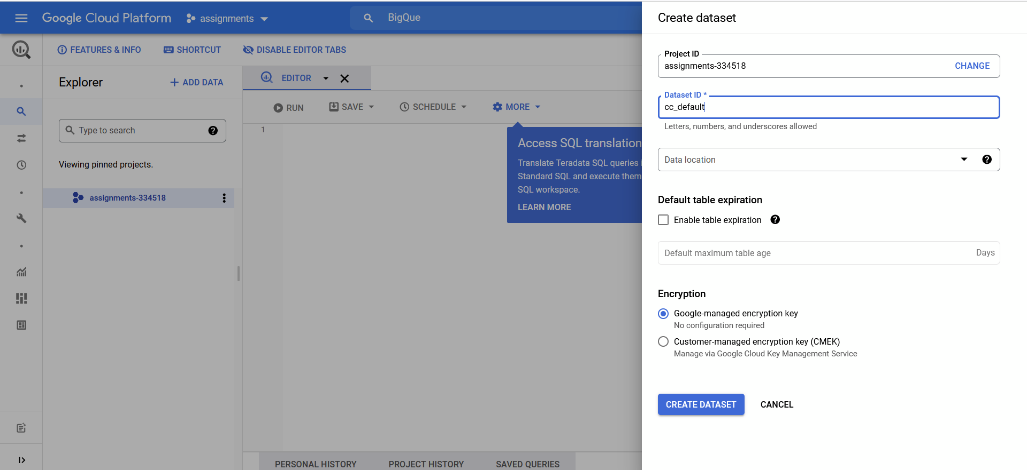

1. Running a query for creating and training the model on BigQuery

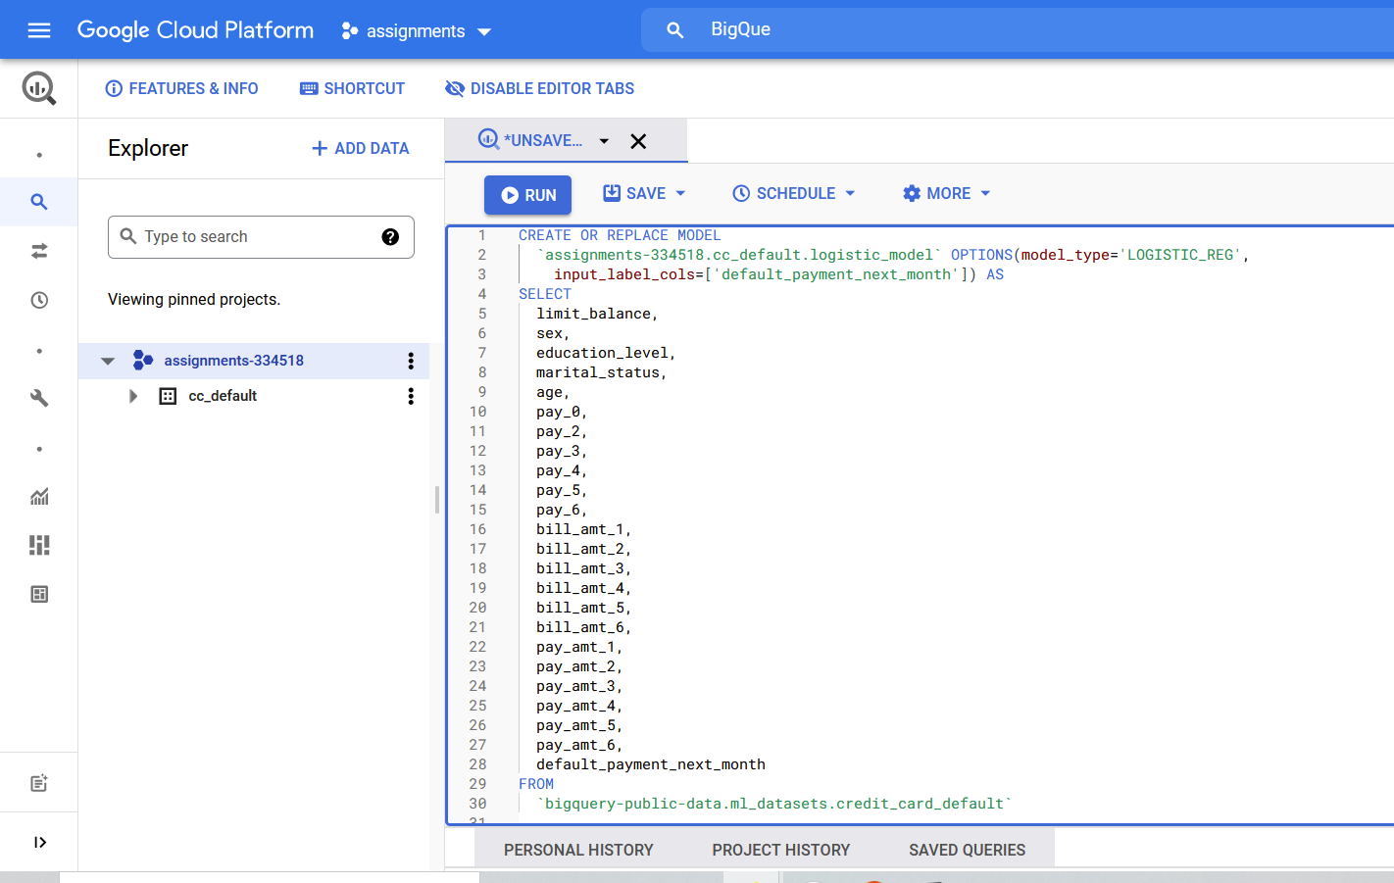

1. Trained model artifact

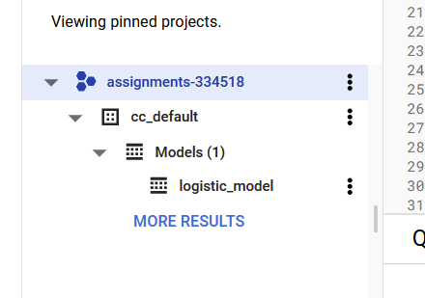

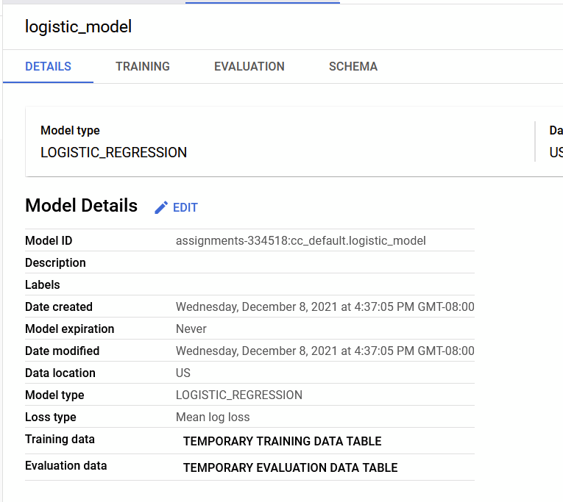

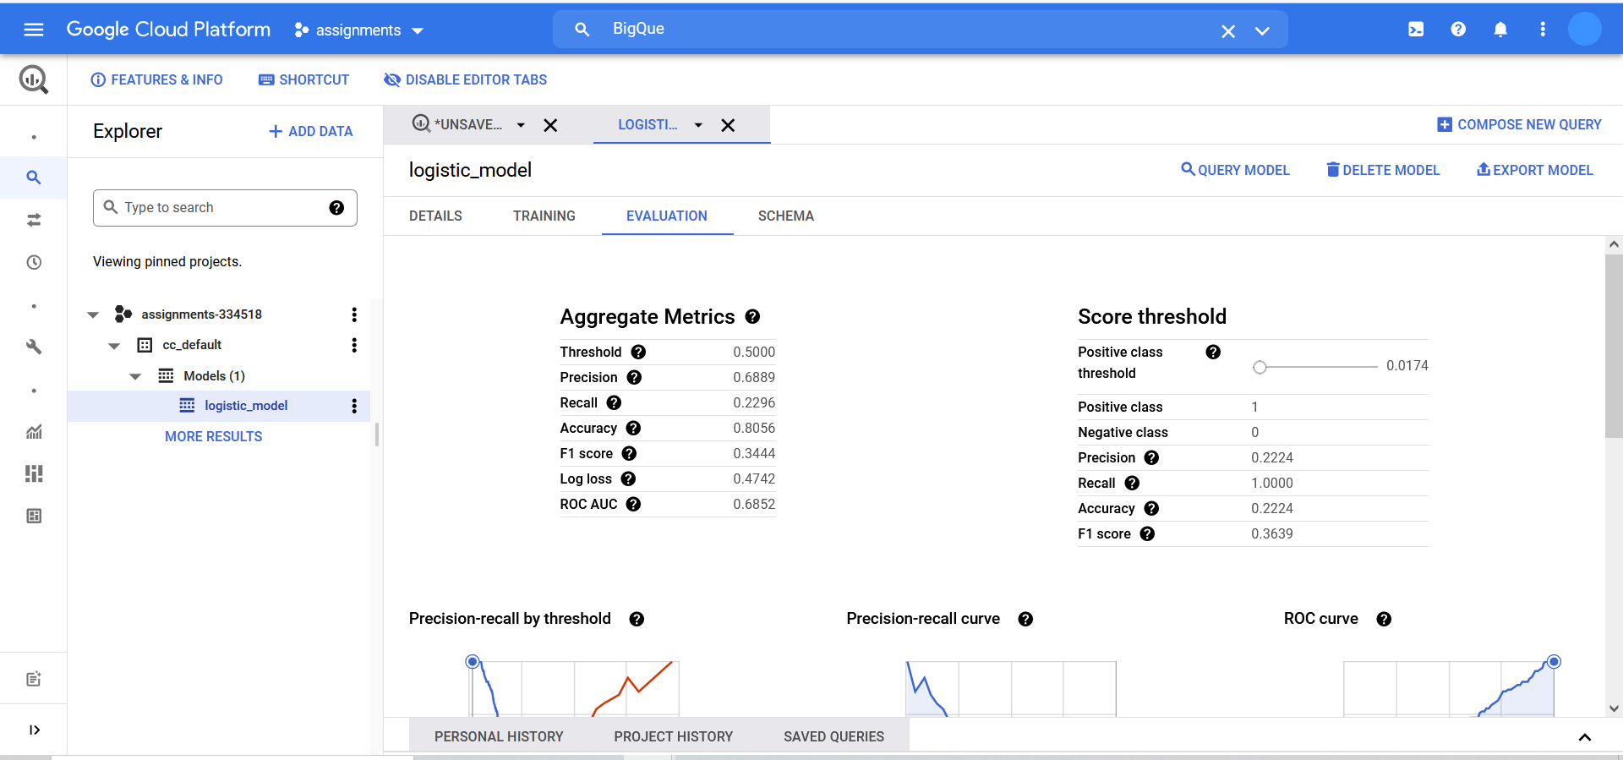

1. Exporting the trained bqml model to a google cloud bucket to be deployed later on vertex AI

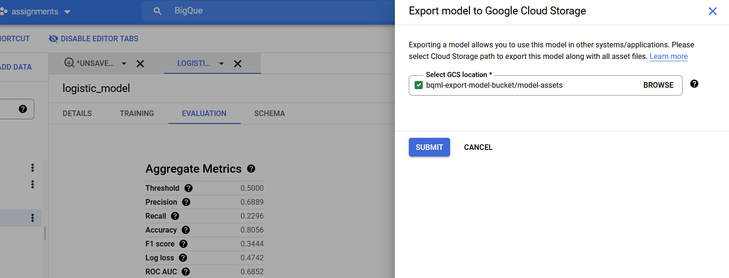

1. Importing the exported bqml model artifacts from the cloud storage bucket to vertex AI for deploying

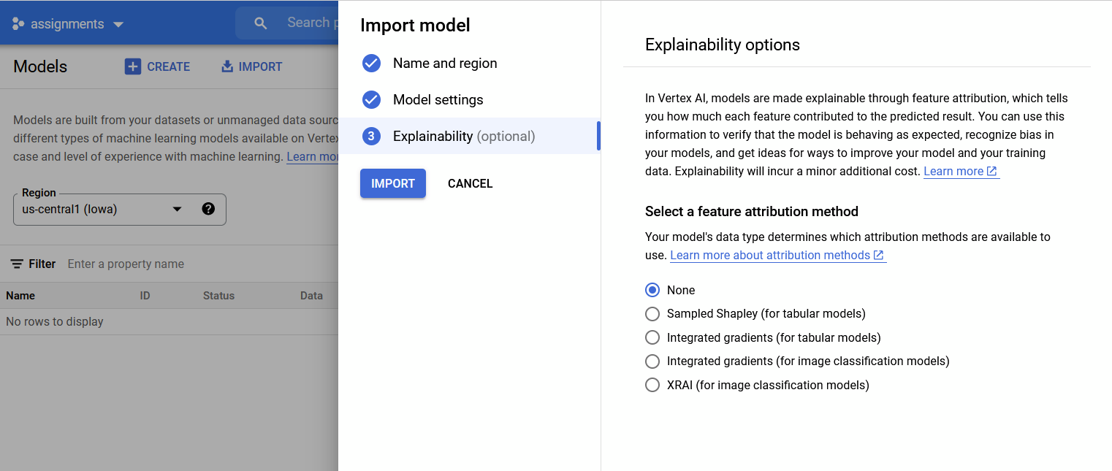

1. Deployed model

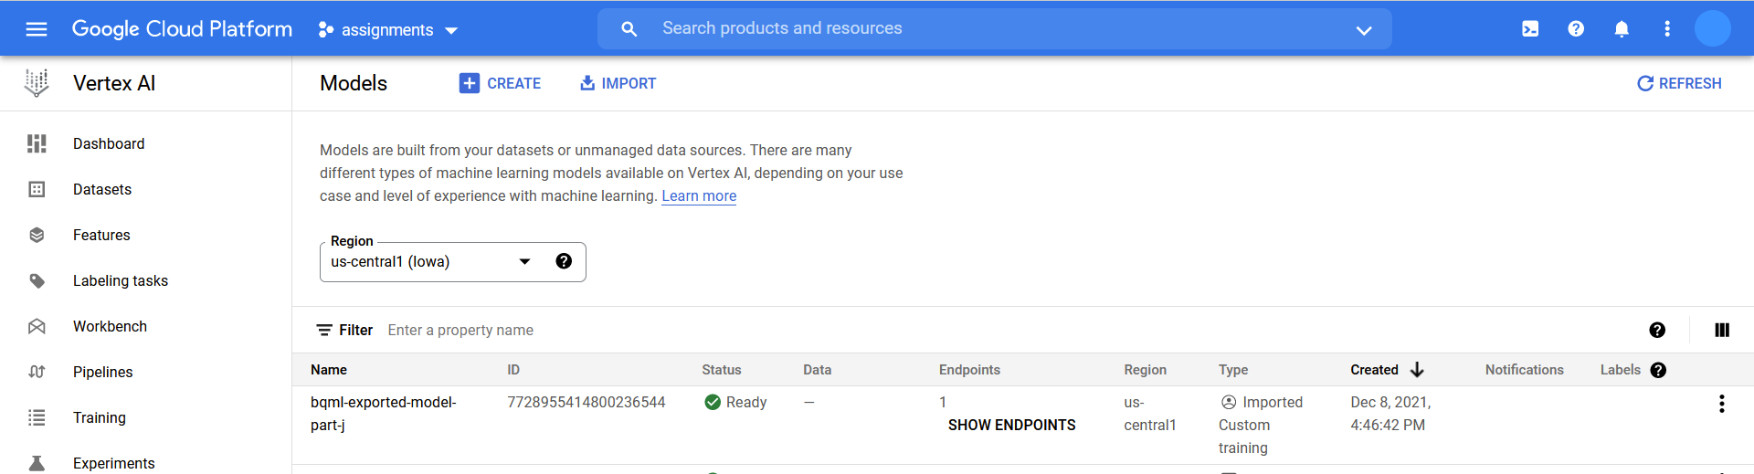

1. Creating a sample request to be sent to the model’s endpoint

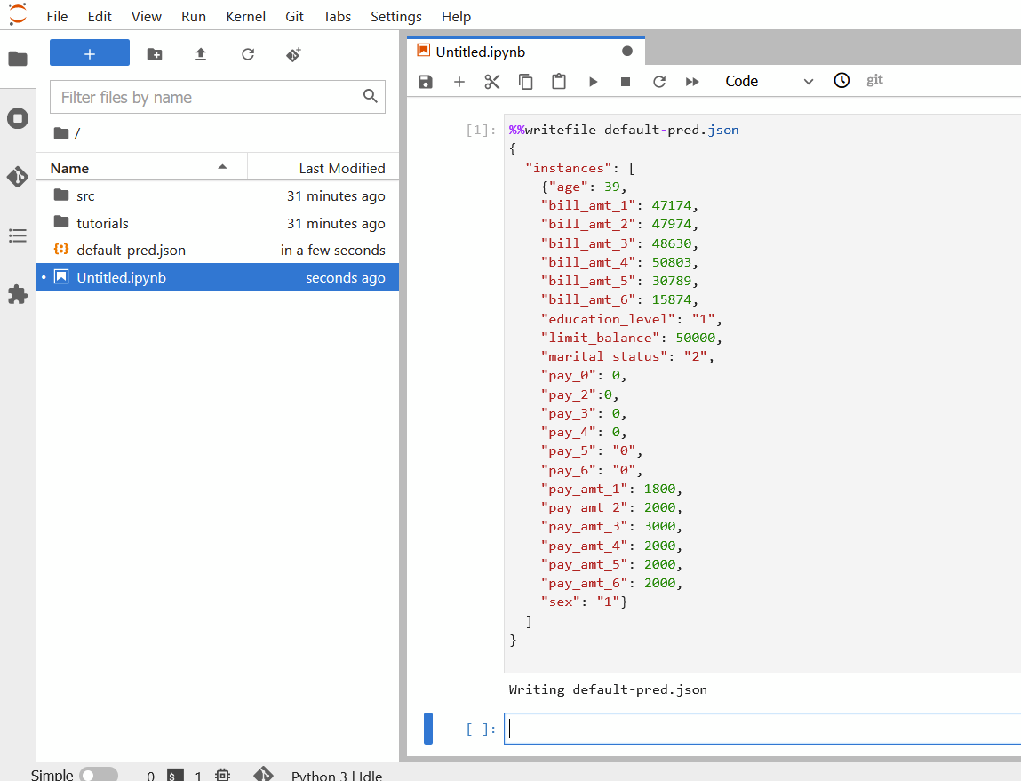

1. The prediction of the model. The "default_payment_next_month_probs" are predicted by the model

